Trivia
Overview
Engage your audience with branded trivia directly within the ad experience. This interactive format is ideal for creating memorable moments and boosting brand recall by blending entertainment with your message.
Trivial reference guide for clients:
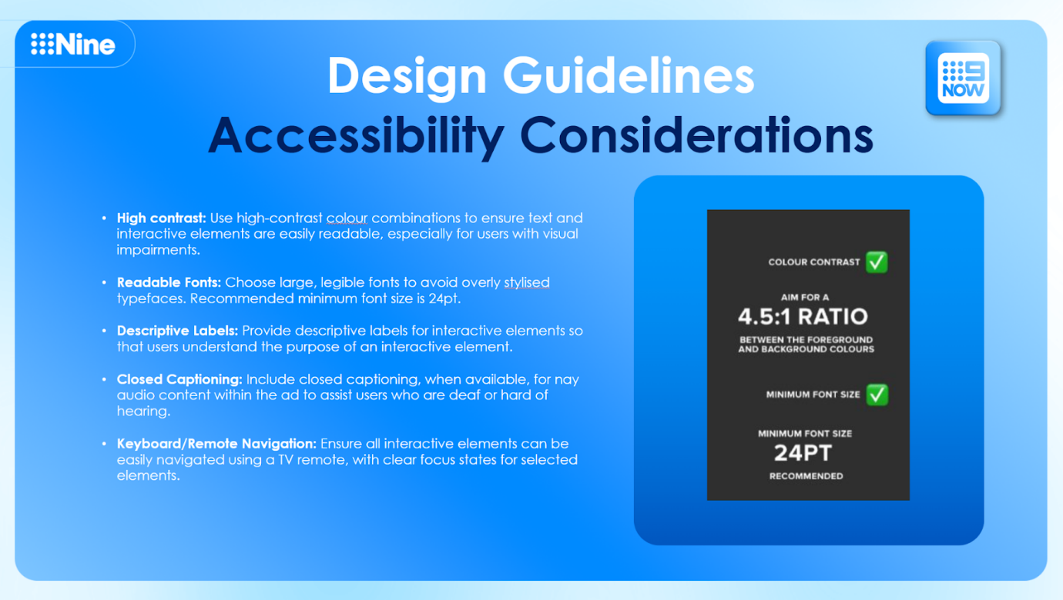
Spec Visualisations
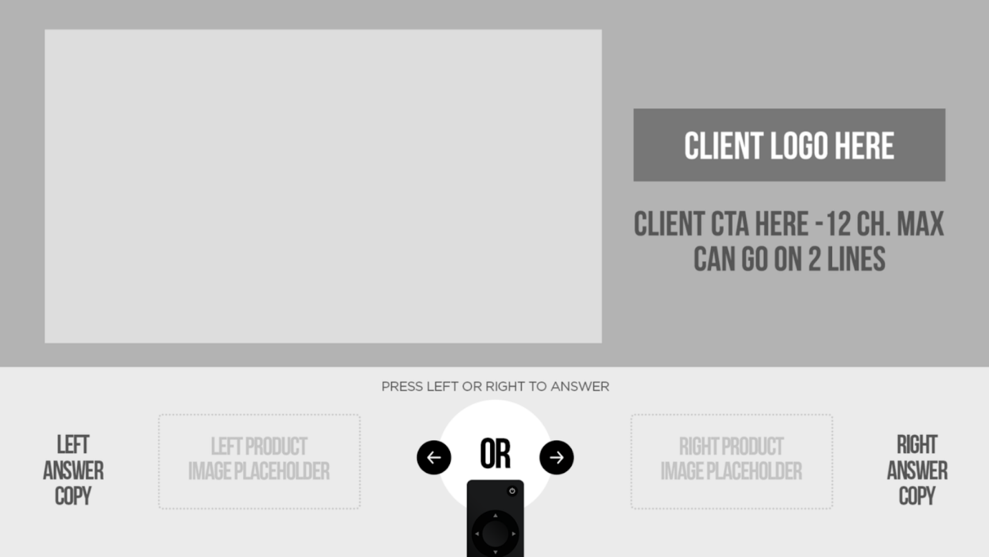
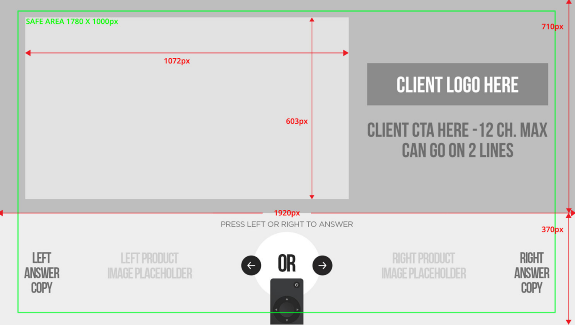
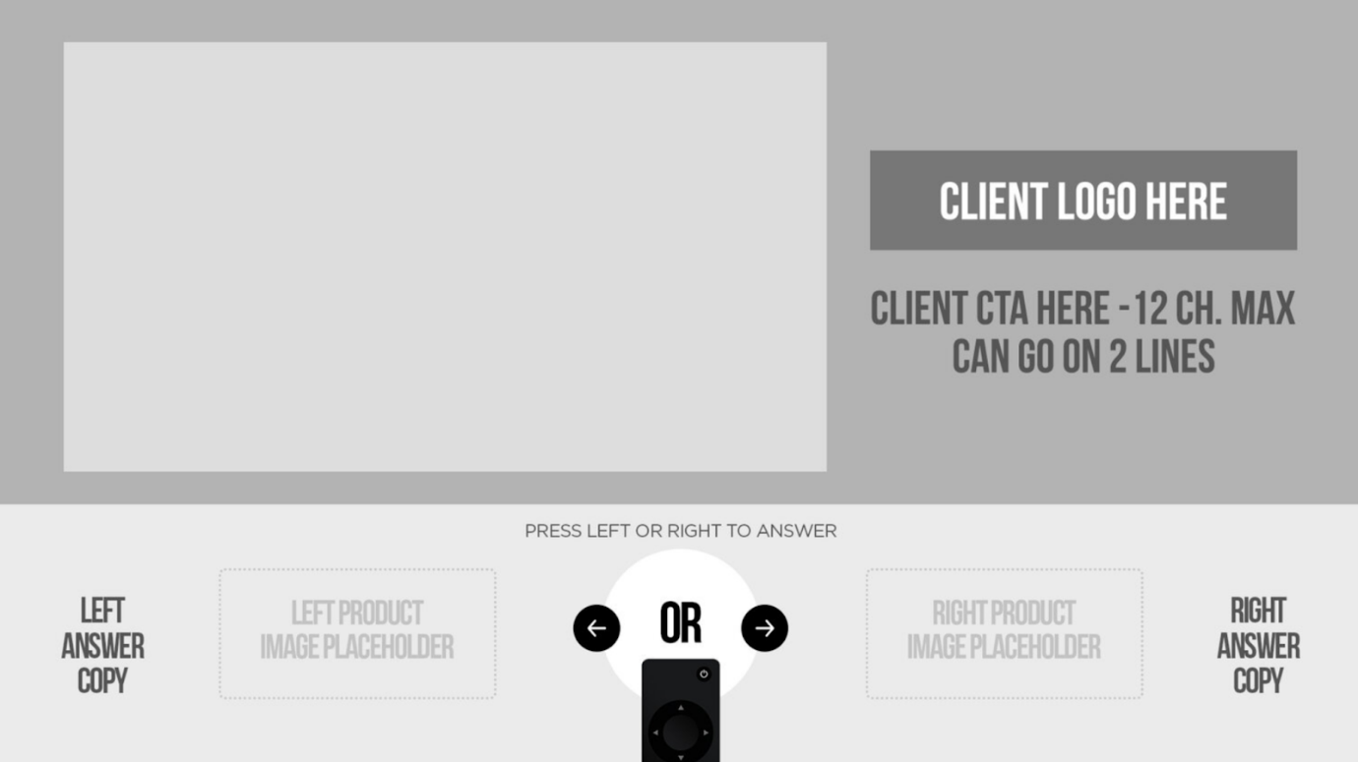
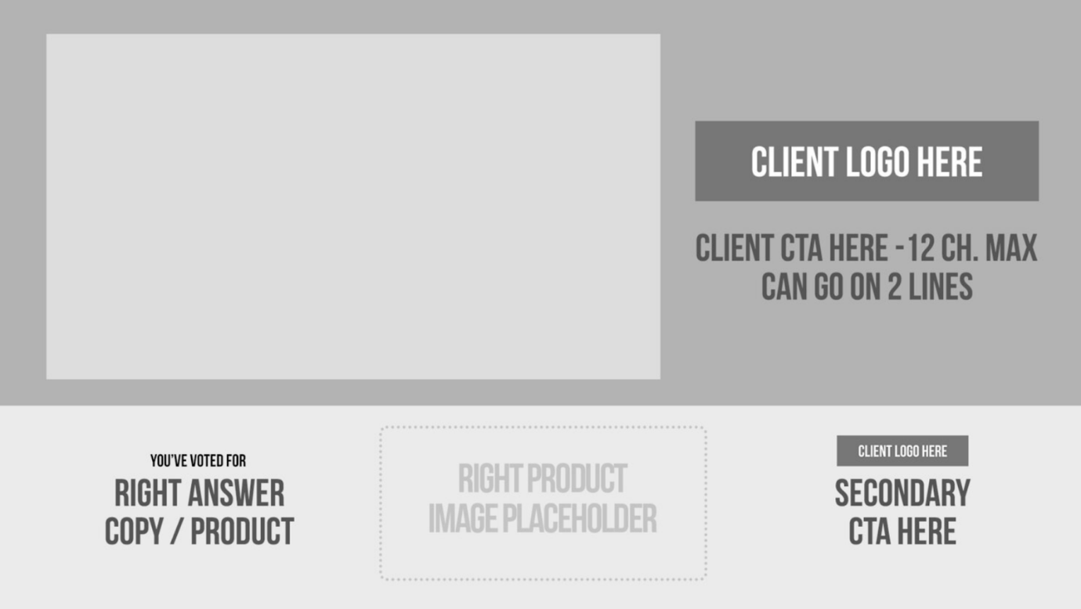
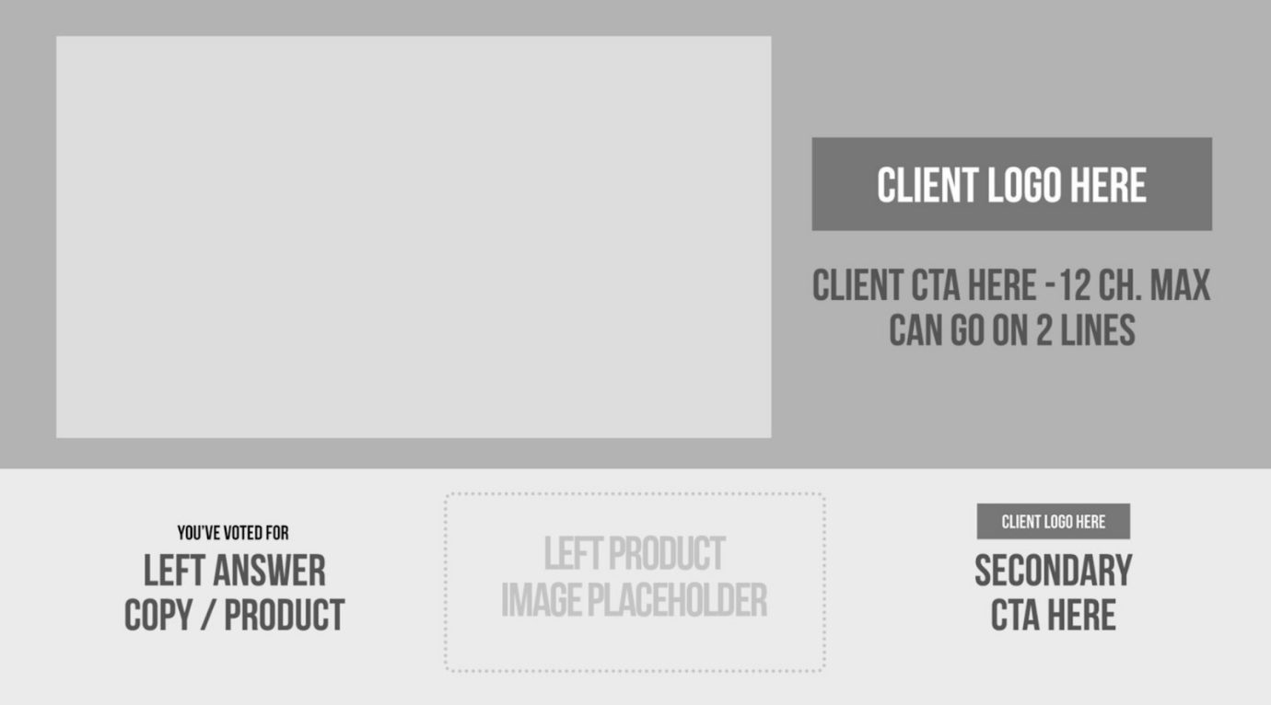

Examples
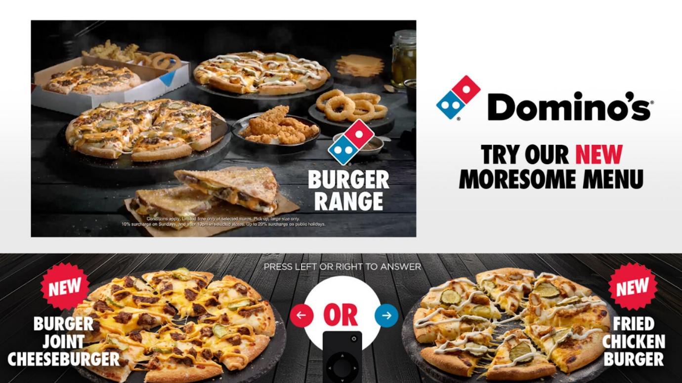
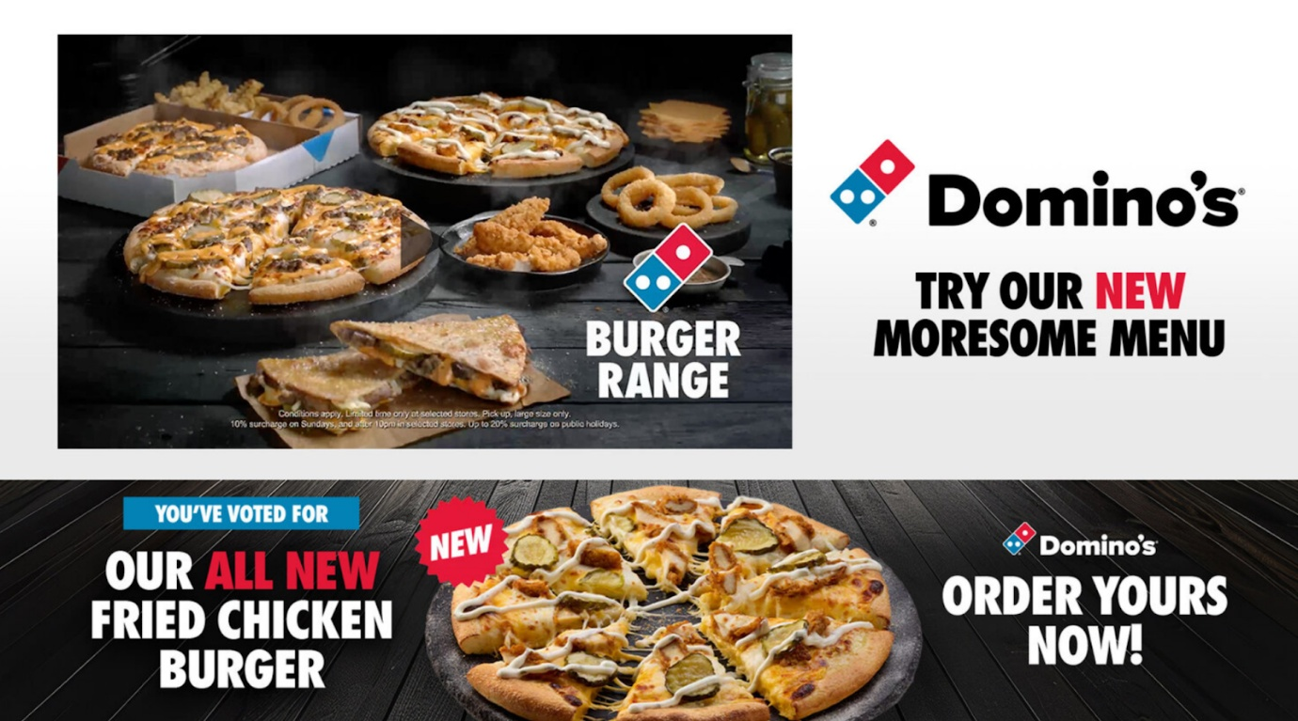
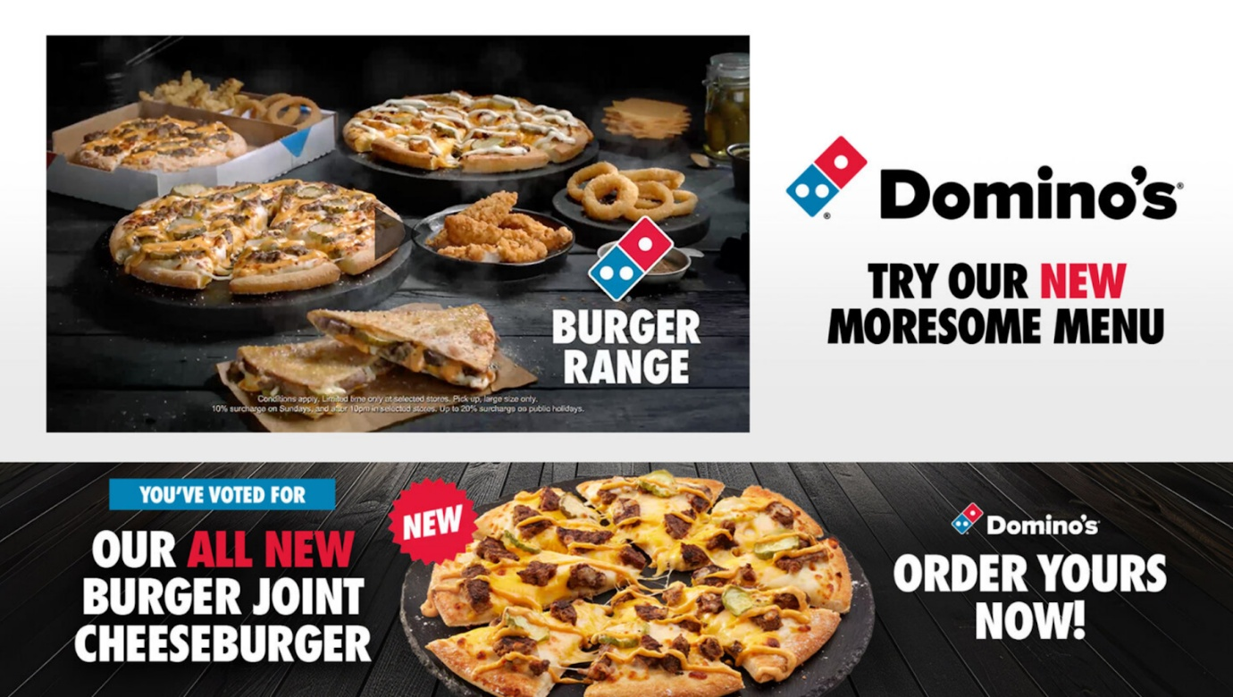
Static Assets
- Branding Elements:
- Logos and fonts
- One trivia question with 2 response options
- Custom background visuals
Video Assets
- File Format: MP4
- Resolution: 1920x1080 HD (16:9 aspect ratio)
- Duration: 30 seconds
- Frame Rate: 25 or 30 fps
- Audio: AAC, 48kHz, stereo
Best Practices
- Relevance: Align trivia questions with your brand or product to ensure meaningful engagement.
- Visual Appeal: Use vibrant visuals or animations to capture attention.
- Clarity: Keep response options short and easy to read.
- Feedback: Provide immediate feedback (e.g., correct/incorrect answers) to encourage interaction.

