Reveal
Overview
The Interactive Reveal adds an element of surprise to your BVOD ad by gradually uncovering a product, offer, or feature. This dynamic format keeps viewers engaged and curious to discover what lies beneath.
Reveal reference guide for clients:
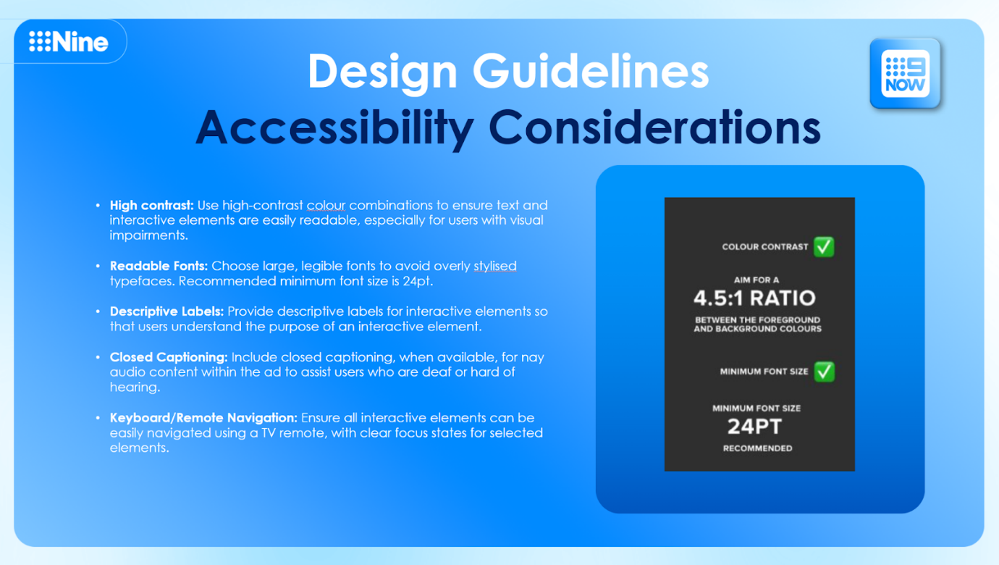

Carousel Spec Visualisation:
Reveal Spec Visuals:
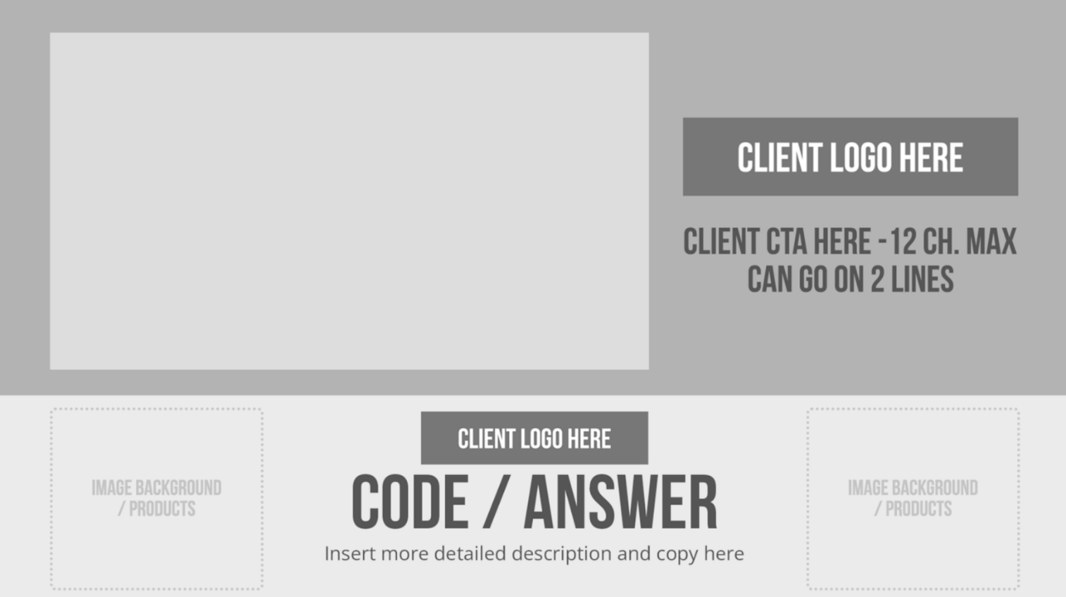
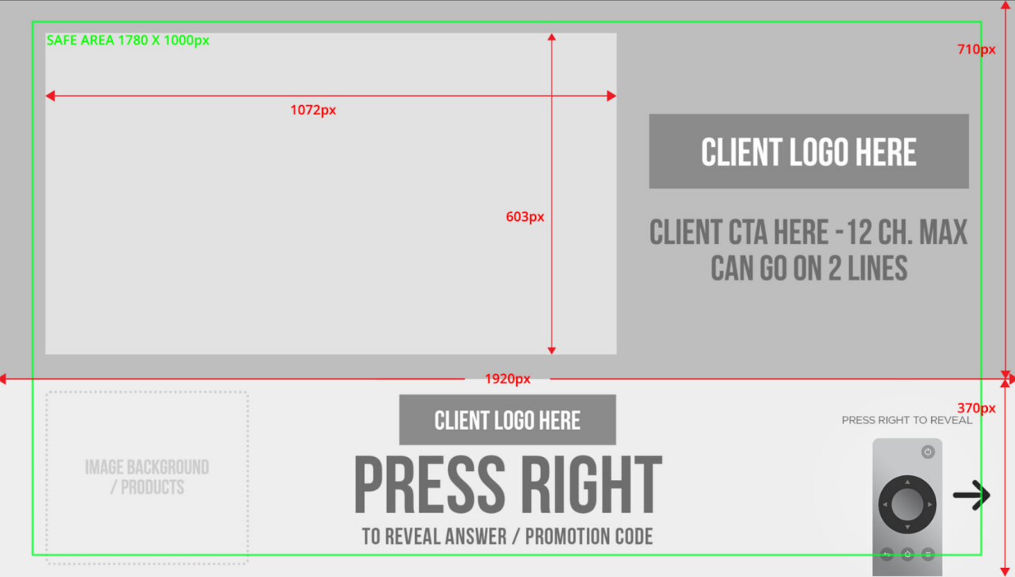
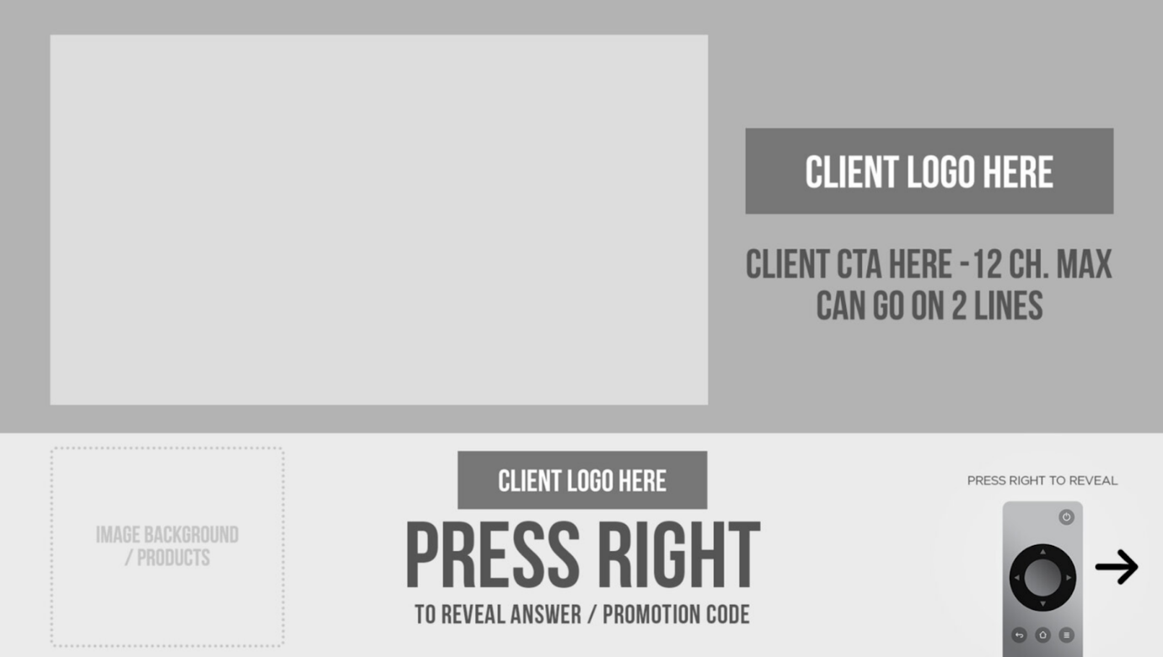
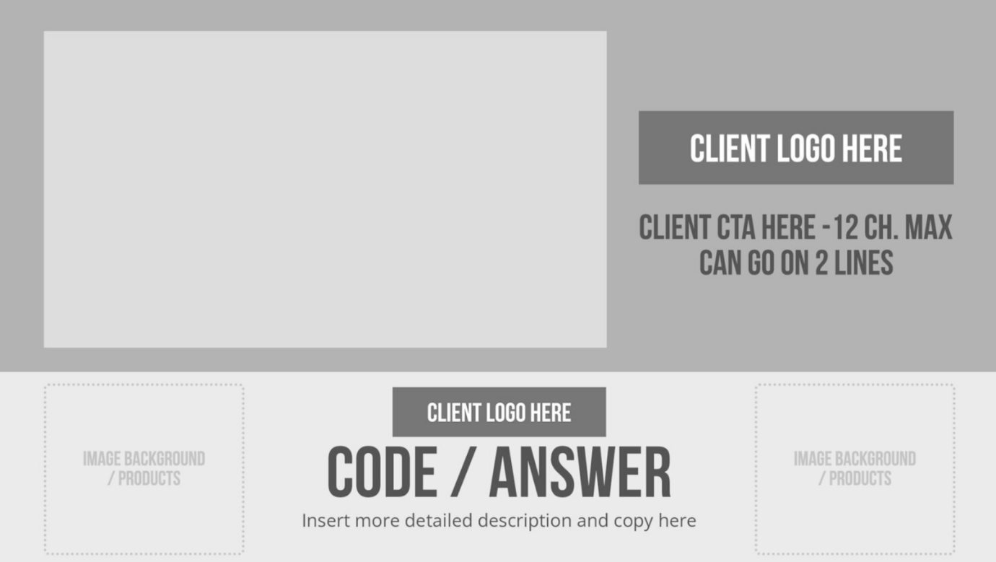

Reveal Examples:


Static Assets
- Branding Elements:
- Logos and fonts
- Hidden elements to be revealed (e.g., product, offer, or feature)
- Copy and CTA for the revealed content

Video Assets
- File Format: MP4
- Resolution: 1920x1080 HD (16:9 aspect ratio)
- Duration: 30 seconds
- Frame Rate: 25 or 30 fps
- Audio: AAC, 48kHz, stereo
Best Practices
- Intrigue: Use visually engaging content to encourage interaction.
- Simplicity: Keep reveal content clear and relevant to your campaign goals.
- Transition: Ensure smooth transitions between hidden and revealed elements.
- Reinforce: Include a strong CTA to drive further action after the reveal.

