Poll
Overview
Interactive Polls allow viewers to share their opinions while engaging with your BVOD ad. This format is perfect for gathering insights or sparking conversations about your brand.
Poll reference guide for clients:
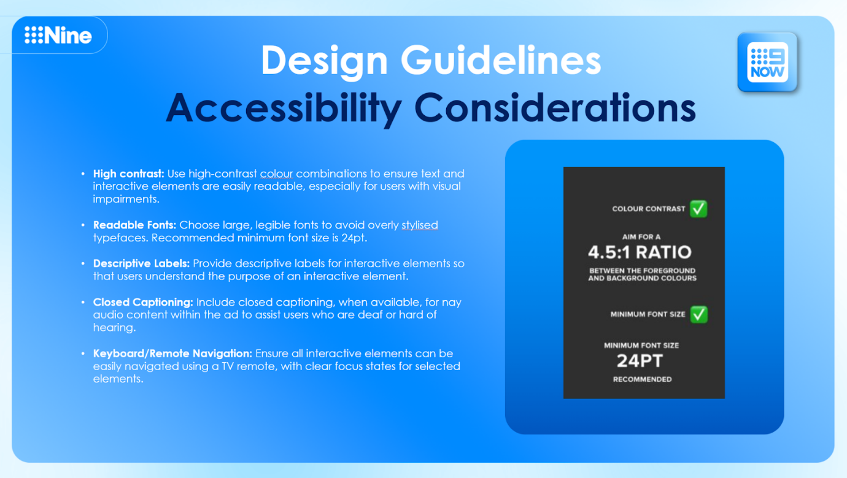
Spec visualisations
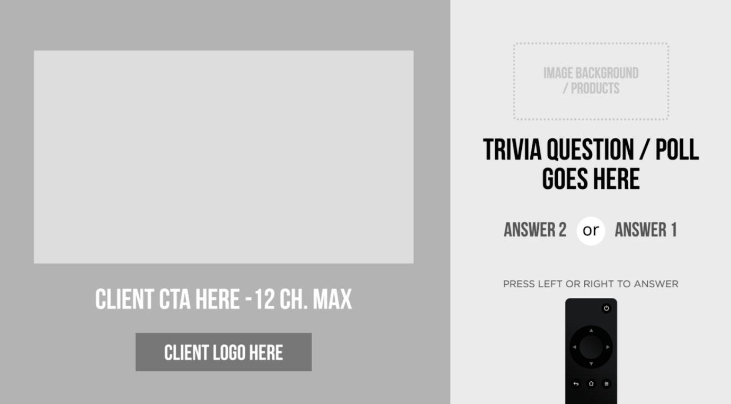
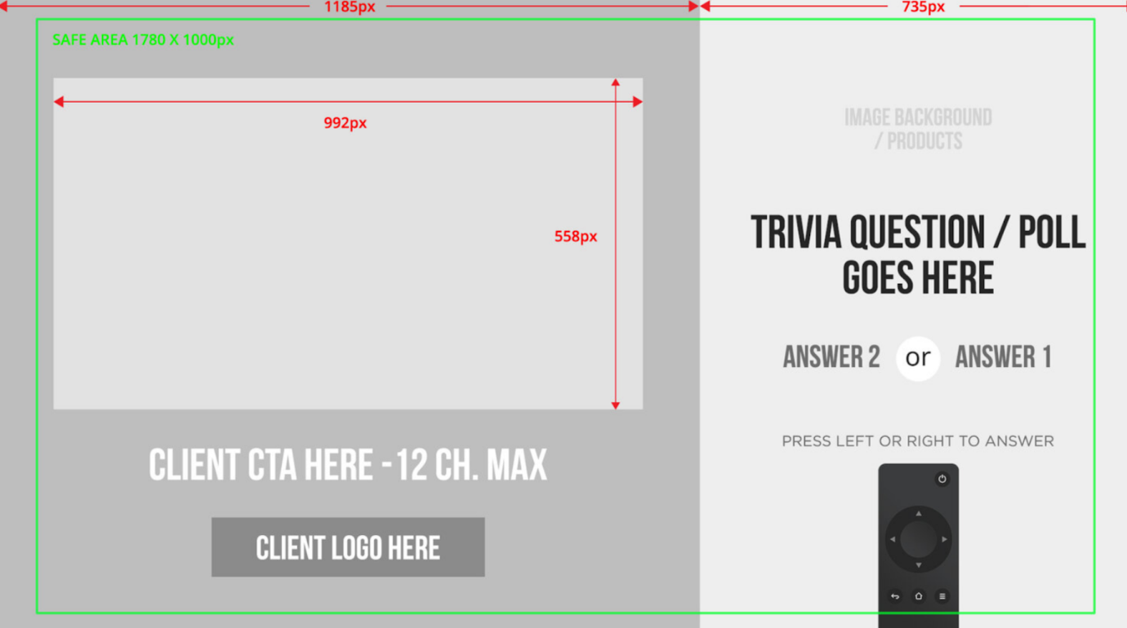
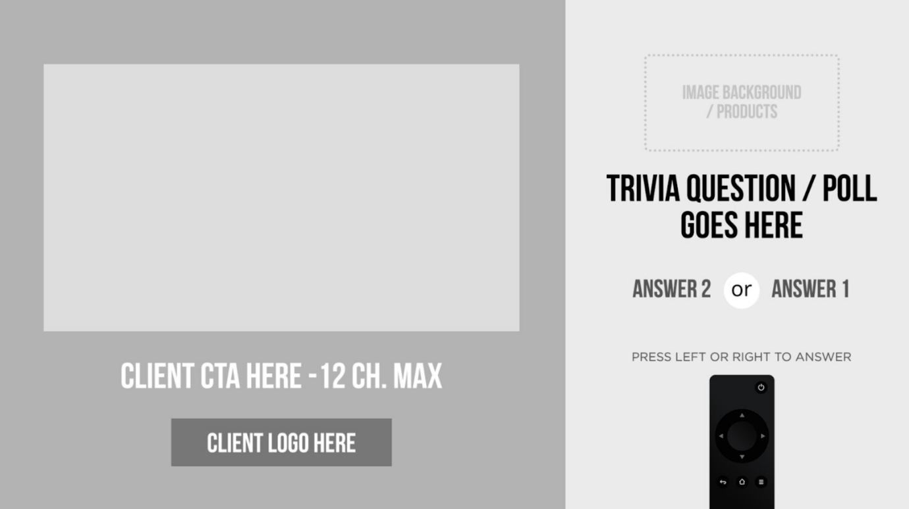
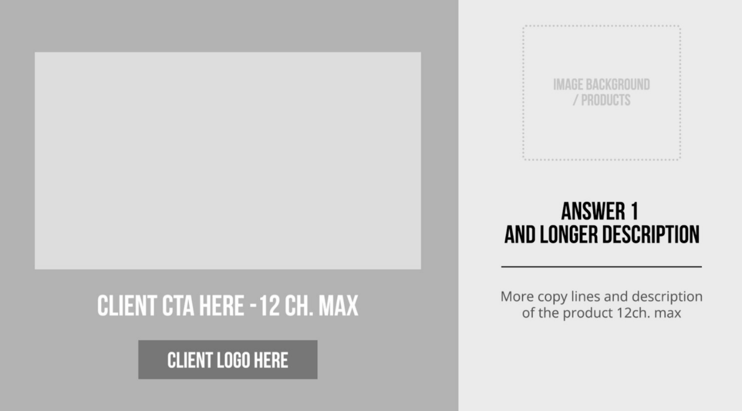
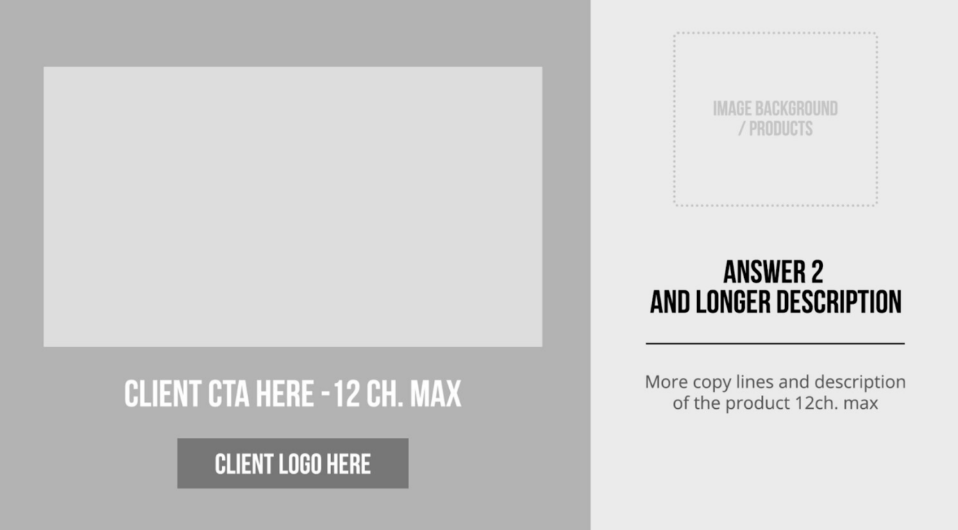

Examples:
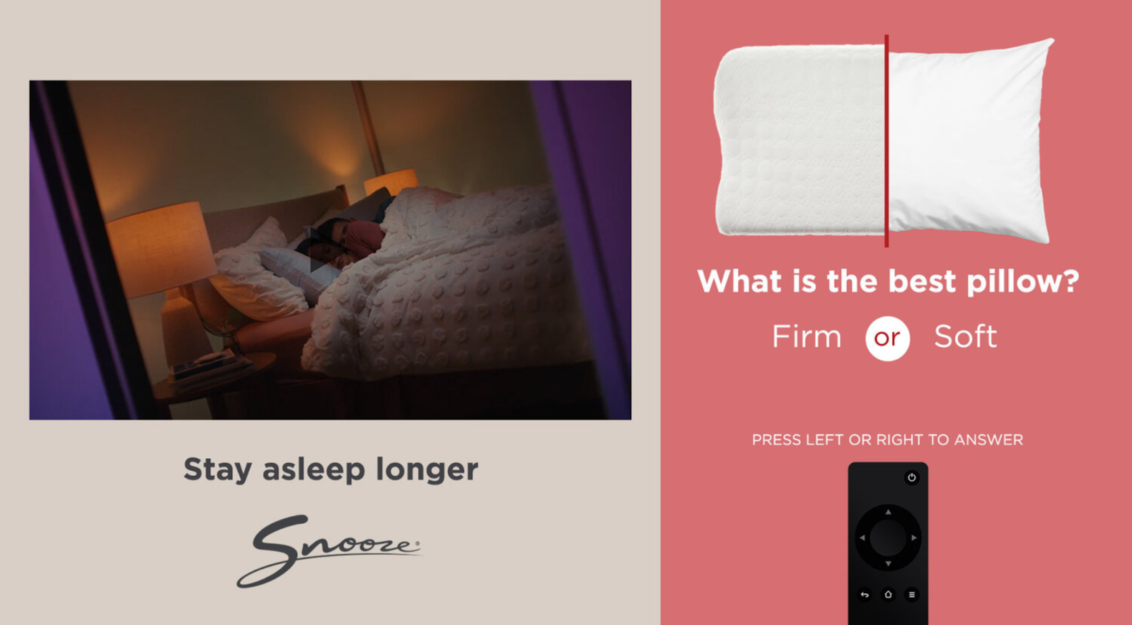
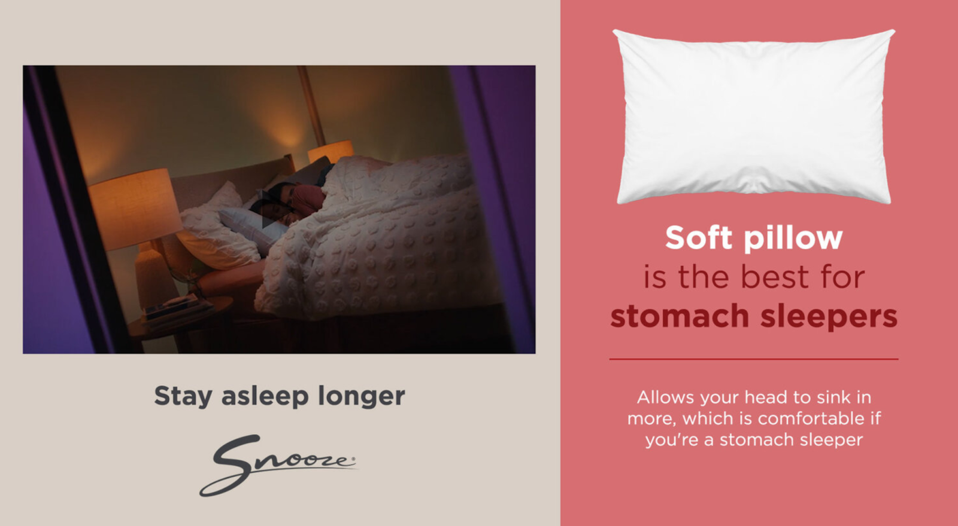
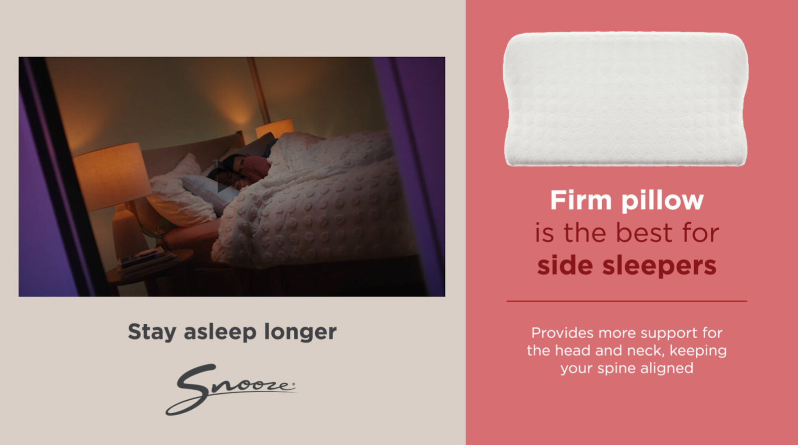
Static Assets
- Branding Elements:
- Logos and fonts
- One poll question with up to 4 response options
- Custom background visuals
Video Assets
- File Format: MP4
- Resolution: 1920x1080 HD (16:9 aspect ratio)
- Duration: 30 seconds
- Frame Rate: 25 or 30 fps
- Audio: AAC, 48kHz, stereo
Best Practices
- Engagement: Keep poll questions simple and relevant to the audience.
- Clarity: Use concise language for both the question and responses.
- Feedback: Show poll results or next steps immediately after participation.

