Interactive Carousel
Overview
The Interactive Carousel transforms your BVOD ad into a swipeable showcase, allowing viewers to explore up to three products, features, or stories directly within the stream. This format creates deeper engagement by enabling viewers to interact with your brand effortlessly.
Carousel reference guide for clients:
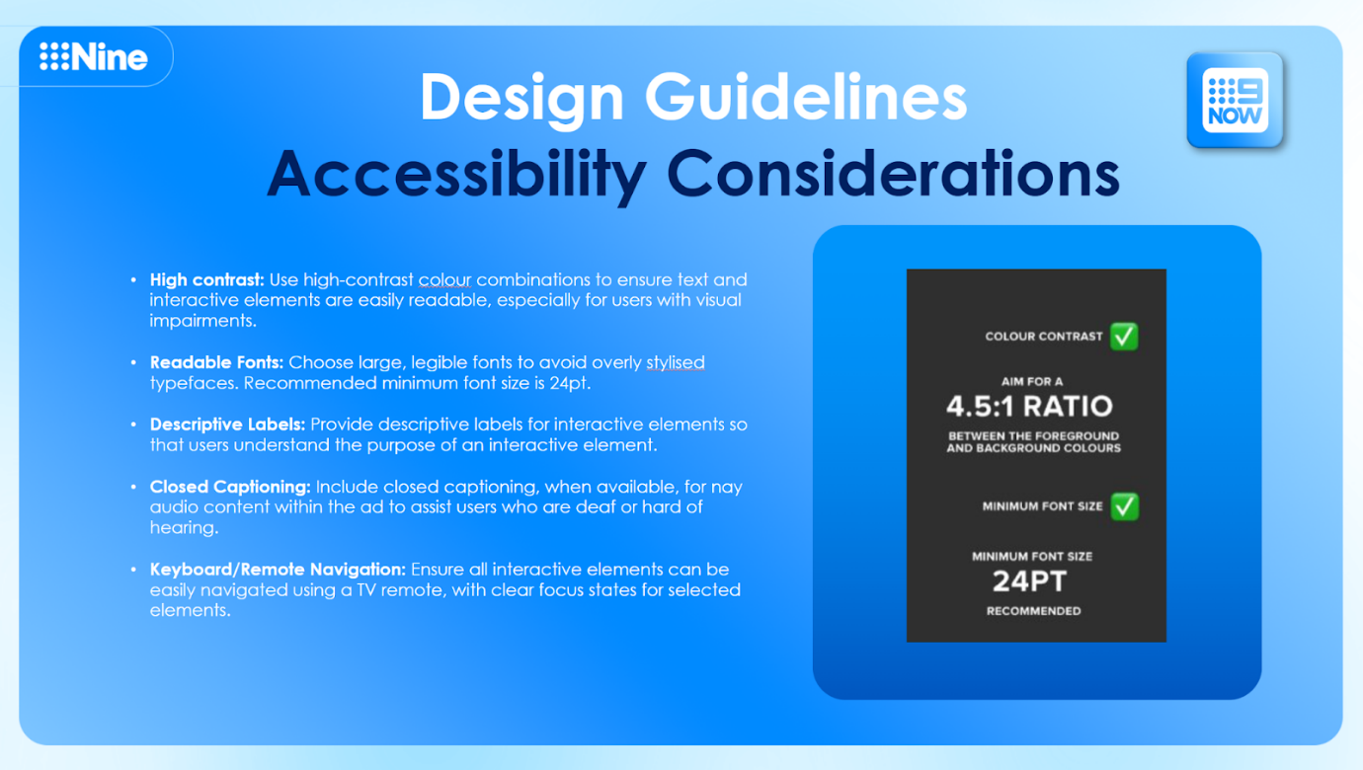
Carousel Spec Visualisation:
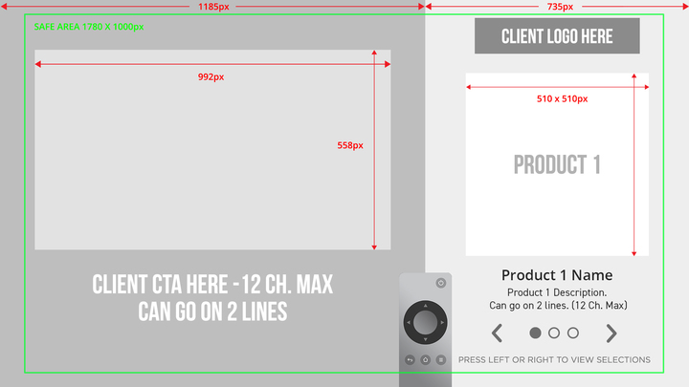
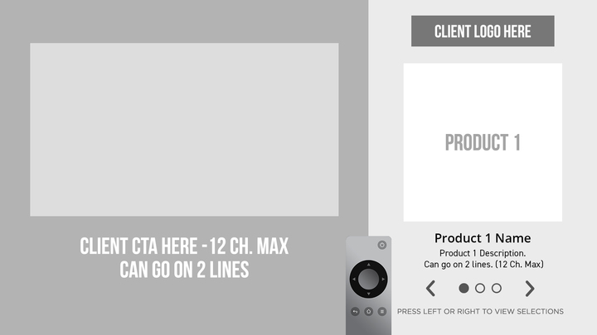
Carousel Examples:
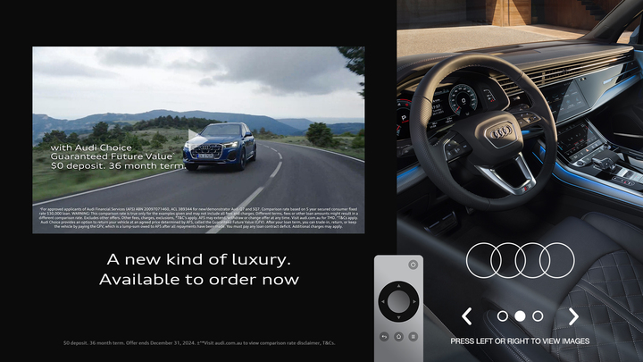


Ad Specs
Static Assets
- Branding Elements:
- Logos and fonts
- Up to 3 product or call-out visuals
- Copy for descriptions and CTAs (maximum 2 lines per card)

Video Assets
- File Format: MP4
- Resolution: 1920x1080 HD (16:9 aspect ratio)
- Duration: 30 seconds
- Frame Rate: 25 or 30 fps
- Audio: AAC, 48kHz, stereo
Best Practices
- Brand Identity: Ensure logos and branding are prominent across all slides.
- Simplicity: Use clear, concise copy to drive engagement (avoid excessive text).
- Consistency: Maintain a uniform design theme across all cards for a cohesive look.
- CTA Placement: Position calls-to-action prominently and consistently across cards.

